Name:- Omkar Joshi
Roll No:- T511042
Div :- TE(A)
Pratical No :- 03
Steps for Creating EC2 Instance

Step 1) In the next step, you have to choose the type of instance you require based on your business needs.
- We will choose t2.micro instance type, which is a 1vCPU and 1GB memory server offered by AWS.
- Click on “Configure Instance Details” for further configurations
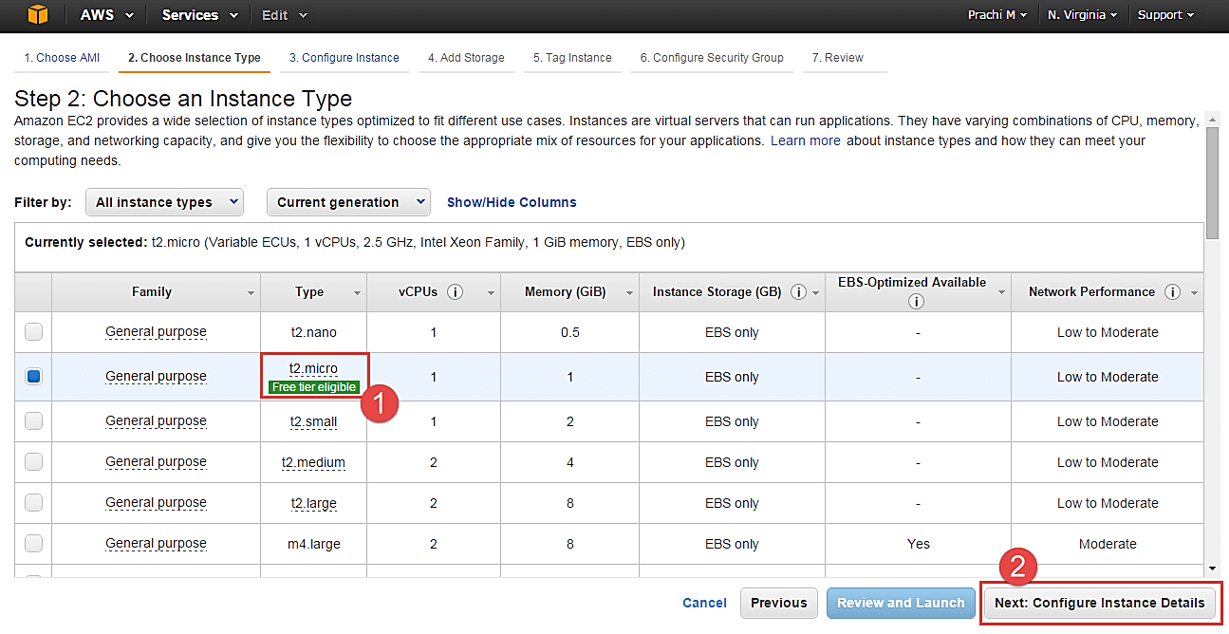
- In the next step of the wizard, enter details like no. of instances you want to launch at a time.
- Here we are launching one instance.

Configure Instance
Step 1) No. of instances- you can provision up to 20 instances at a time. Here we are launching one instance.
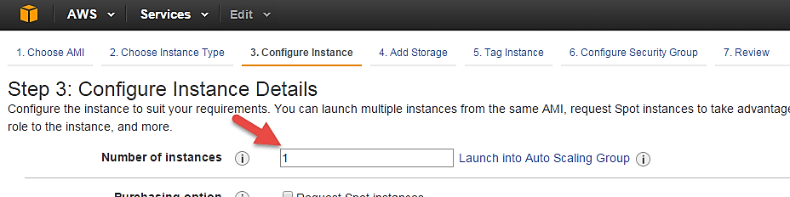
Step 2) Under Purchasing Options, keep the option of ‘Request Spot Instances’ unchecked as of now. (This is done when we wish to launch Spot instances instead of on-demand ones. We will come back to Spot instances in the later part of the tutorial).
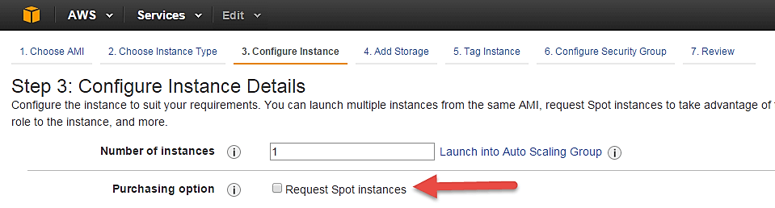
Step 3) Next, we have to configure some basic networking details for our EC2 server.
- You have to decide here, in which VPC (Virtual Private Cloud) you want to launch your instance and under which subnets inside your VPC. It is better to determine and plan this prior to launching the instance. Your AWS architecture set-up should include IP ranges for your subnets etc. pre-planned for better management. (We will see how to create a new VPC in Networking section of the tutorial.
- Subnetting should also be pre-planned. E.g.: If it’s a web server you should place it in the public subnet and if it’s a DB server, you should place it in a private subnet all inside your VPC.
Below,
- Network section will give a list of VPCs available in our platform.
- Select an already existing VPC
- You can also create a new VPC
Here I have selected an already existing VPC where I want to launch my instance.
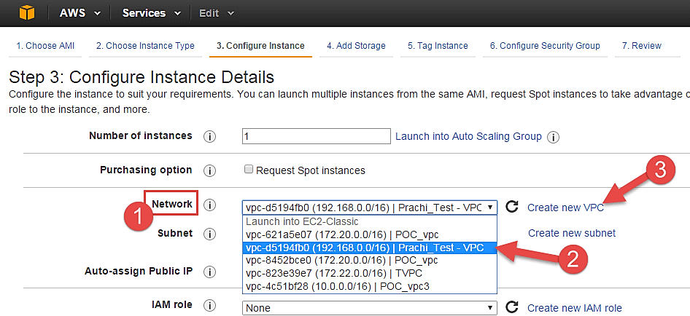
Step 4) In this step,
- A VPC consists of subnets, which are IP ranges that are separated for restricting access.
- Below,
- Under Subnets, you can choose the subnet where you want to place your instance.
- I have chosen an already existing public subnet.
- You can also create a new subnet in this step.
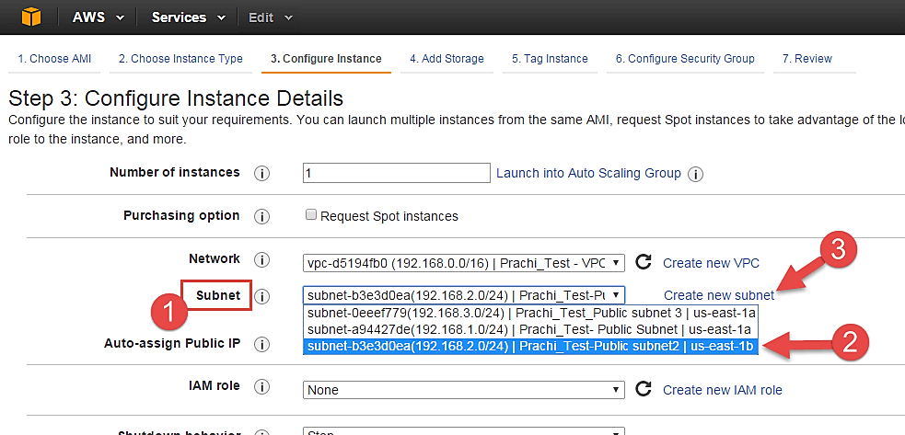
- Once your instance is launched in a public subnet, AWS will assign a dynamic public IP to it from their pool of IPs.
Step 5) In this step,
- You can choose if you want AWS to assign it an IP automatically, or you want to do it manually later. You can enable/ disable ‘Auto assign Public IP’ feature here likewise.
- Here we are going to assign this instance a static IP called as EIP (Elastic IP) later. So we keep this feature disabled as of now.
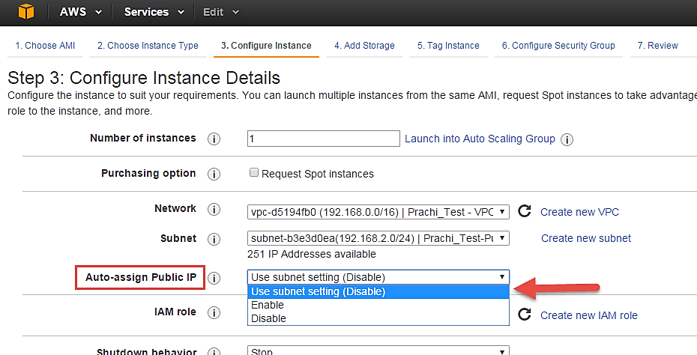
Step 6) In this step,
- In the following step, keep the option of IAM role ‘None’ as of now. We will visit the topic of IAM role in detail in IAM services.
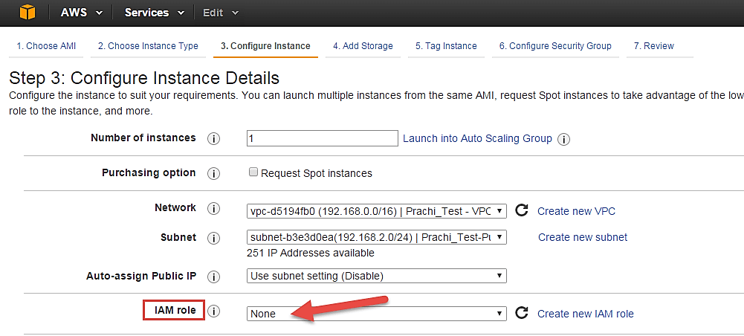
Step 7) In this step, you have to do following things
- Shutdown Behavior – when you accidently shut down your instance, you surely don’t want it to be deleted but stopped.
- Here we are defining my shutdown behavior as Stop.
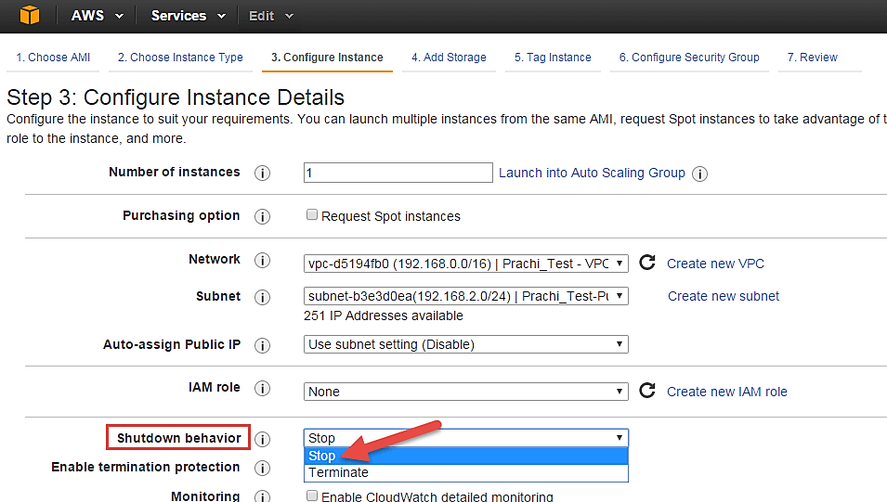
Step 8) In this step,
- In case, you have accidently terminated your instance, AWS has a layer of security mechanism. It will not delete your instance if you have enabled accidental termination protection.
- Here we are checking the option for further protecting our instance from accidental termination.
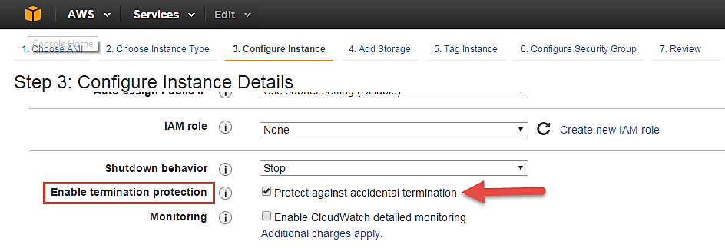
Step 9) In this step,
- Under Monitoring- you can enable Detailed Monitoring if your instance is a business critical instance. Here we have kept the option unchecked. AWS will always provide Basic monitoring on your instance free of cost. We will visit the topic of monitoring in AWS Cloud Watch part of the tutorial.
- Under Tenancy- select the option if shared tenancy. If your application is a highly secure application, then you should go for dedicated capacity. AWS provides both options.
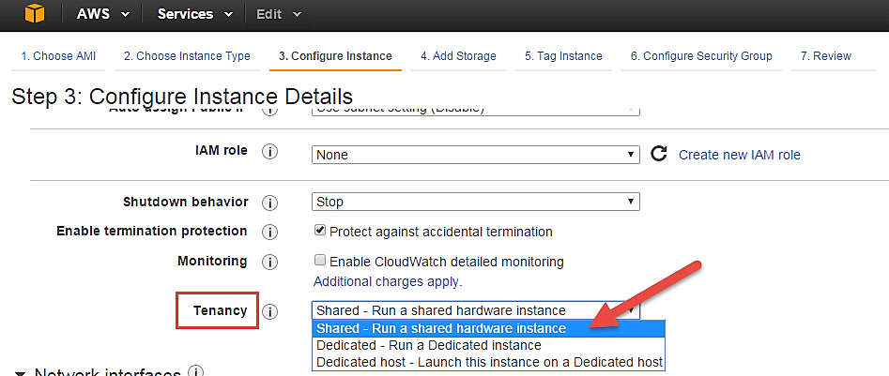
Step 10) In this step,
- Click on ‘Add Storage’ to add data volumes to your instance in next step.
